Search and download Anaconda or Miniconda from the official website: <https://www.anaconda.com/>

https://docs.conda.io/projects/conda/en/latest/user-guide/install/index.html

After the installation, go to the menu and find the Anaconda folder and unfold it to open the powershell. Please use the “***Anaconda Powershell Prompt***”

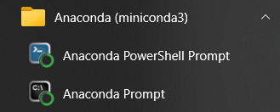

Use “***conda env list***” to show the existing virtual environments:

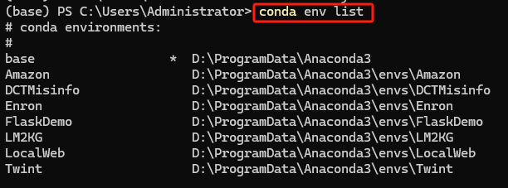

Use “***conda create --name Envname python=version***” to create an environment for a specific project.



Replace “Envname” with whatever name you want to use, just make it clear for your own recognition.

After the environment is created, use “***conda activate Envname***” to activate the environment.



The activated environment will be displayed in front of the command line:



Then use “***pip install jupyterlab***” to install jupyter lab



After the installation, use “***jupyter lab***” to open it so that you can see it in your browser:



In the future when you want to install any other python packages, you can come back to the shell and use “***pip install packagename***” same as you install jupyterlab. Or you can also install in the jupyter cell with “!” in front of “pip” and then run the cell:



If you don’t want to use the default directory in jupyter lab listed on the left side, please use the “cd” command in the powershell to locate your workspace like:

Or you can go to “C:\Users\Administrator\.jupyter” and find the file “jupyter_lab_config.py”.

Open it and search “c.ServerApp.root_dir” and locate it. Then uncomment it and assign the root path that you want it to show. Save and restart jupyter lab, the default directory will change to the one you newly assigned.

